cyborg7
Dungeon of Dragons
Documentation
Version 1

All work Copyright © 2012 by XX Games.
All rights reserved.

By: Gurinder Verma


January 30th 2015

Table of Contents
Version History 3
Game Overview 4
Game Play Mechanics 4
Controls 4
Saving and Loading 4
Interface Sketch 4
Menu and Screen Descriptions 5
Game World 6
Levels 6
Game Progression 8
Characters 8
Non-player Characters 8
Enemies 8
Items 8
Cheat Codes 8
Design Notes 8
Future Features 9
References 9

Version History
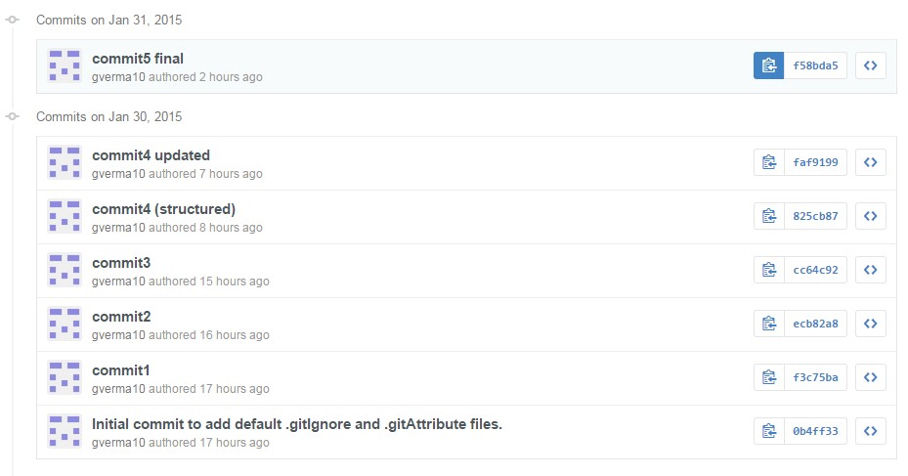

Game Overview
This is a game about the right choices made by the Prince of Skyros. His territory was attacked by the all evil forces and the princess was kidnaped by their enemies during the attack. When the prince returns he saw everything devastated and in full rage sets out of the castle for the Dungeons to get the princess back. With your knowledge and courage help the prince to get his princess back.

Game Play Mechanics
The game will move on the selections made by the player. At each next level he cross towards the princess, prince has to face a dilemma of choosing the correct path which will lead him to the rescue.

Controls
The only control that could be used in this game is the mouse. The user can select the available options though the click of the mouse.

Saving and Loading
No such feature as saving and loading has been added so far, but could be implemented in the upcoming versions.

Interface Sketch
The game interface will give the storyline of the game as the player moves ahead with his all intelligence.
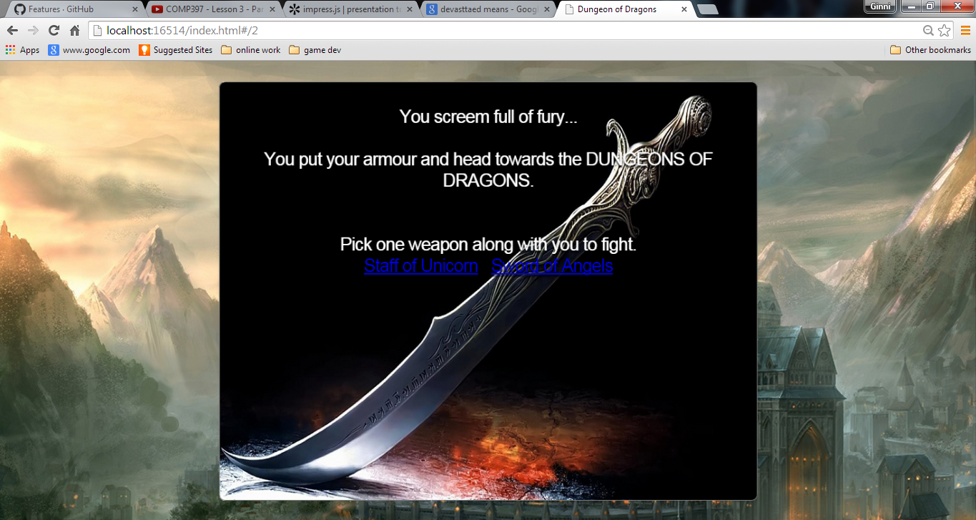

Menu and Screen Descriptions
The game have a menu which gives the user a little plot about the game before starting it.
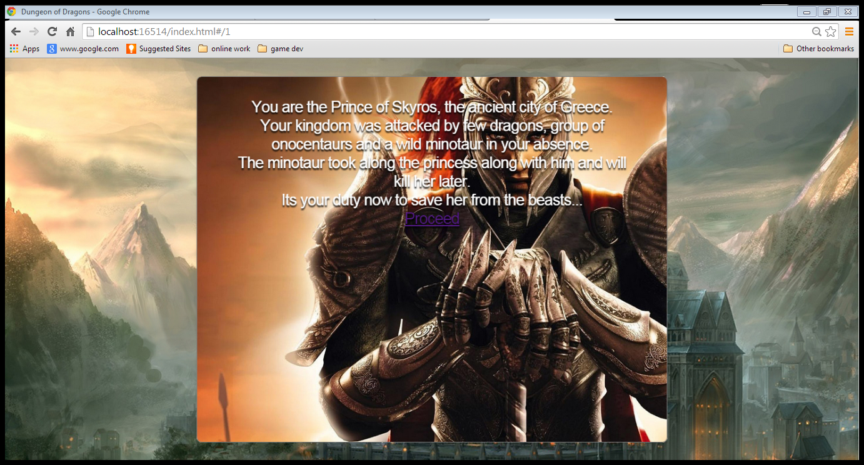

Game World
The game is based on the virtual world of the ancient city of Greece, ‘Skyros’. It’s a 2D graphical game.

Levels
Basically looking towards the plot of the game it has been divided into three levels, on each level of the game the player is provided with the two options which may or may not lead to the victory.

The begins with the plot and let the user understand what he is going to get into.

NODE 1: at this node the player is provided with the two options to choose the weapon to fight with his enemies. The options to the user are staff or sword.

NODE 2: at this node the player is already with the staff and to gain more special item for the game is given with two options. The special item depends over the selected option.

NODE 3: at this node the player is already with the sword and further two options are provided to him, first for the shield and second for the compass.

NODE 4: at this node the player gets the wings along with his staff and faces the dragon. To face the dragon the player is given two options to choose from.

NODE 5: at this node the player get the dagger along with his staff and faces the dragon.
To face the dragon the player is given two options to choose from.

NODE 6: at this node the player get the shield along with his sword and faces a troop of onocenteurs. To face them the player is given two options to choose from.

NODE 7: at this node the player get the compass along with his sword and faces the Minotaur and finds the princess. In order to rescue the princess he needs to defeat the Minotaur. To face Minotaur the player is given two options to choose from.

OUTCOME 1: You decide to protect yourself with wings, but the dragon turns you into ashes with his blow and you fail.

OUTCOME 2: You decide to attack with the staff and you defeat the dragon but unfortunately was not able to save the princess and you fail.

OUTCOME 3: You decide to attack the dragon with the dagger and the dragon in return attacked you and killed you and you fail.

OUTCOME 4: You decide to attack the dragon with your staff but the power of dragon turn you evil and you left the princess and you fail.

OUTCOME 5: You decided to attack the troop with the sword, but they outweighs you in number and strength hence you get killed and you fail.

OUTCOME 6: You decided to shield from their attacks, but the shield could not take their harsh attack for long and broke putting you to death and you fail.

OUTCOME 7: You decided to attack the Minotaur with your sword but he was more in strength as compared to you and killed you and you fail.

OUTCOME 8: You decided to dodge the attacks of Minotaur and attack on the perfect moment and you defeated him and saved the princess and you succeed.

Game Progression
The game progresses level by level, which depends upon the selections made by the player.

Characters
There is no physical character in the game but as its role play game, the player is the prince of the city of Skyros.

Non-player Characters
The non-playing character in this game is the princess, whom the princes has to rescure from his enemies.

Enemies
The princes has many enemies like dragons, onocentaurs and minotaur. The main enemy is considered to be the minothaur as he was the one who kidnapped the princess.

Items
At each level the player is being given a special item which will help him to get to the final level.

Cheat Codes
No cheat codes are applicable for this game so far as the difficulty level is not much. But could be considered in the forthcoming versions.

Design Notes
The designing of the game is kept simple to make it more user friendly. And the images used are from the various external sources.

Future Features
In future the new features could be introduces like 3D characters, virtual weapons, sound effects, graphical rendering, etc.

References
The images used in this are taken from various sources
- Google images
- Hdwallpaers
- Superbwallpaers
- Wallpapersguy

